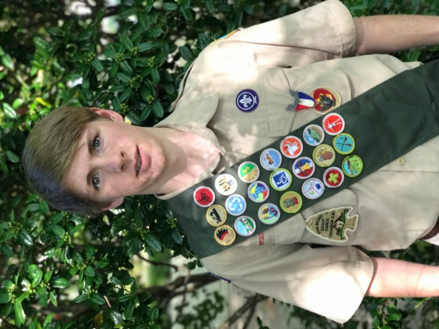
Nick Bennett began his scouting adventures when he joined Troop 455 in 2010. While a member of the Troop, Nick served as Quartermaster, Assistant Patrol Leader and Patrol Leader. He never met a troop outing he didn’t like including his 2013 trip to Philmont.
For his Eagle Project, Nick constructed wood duck boxes and installed them in the fly zone in the Mississippi Delta.
Nick is the son of Emily and Steve Bennett and is a senior at Woodward Academy.

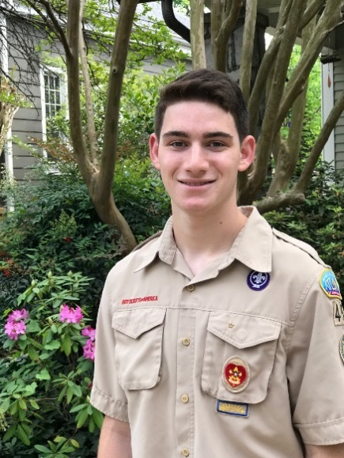
Dominc Coletta started as a Cub Scout at age 8 and advanced to Boy Scouts with Troop 455. He has served as Patrol Leader, Assistant Patrol Leader and Camp Counselor at Bert Adams Scout Reservation.
During his years as a Scout, Dominic especially enjoyed the rafting and shooting outings and hiking Philmont Ranch in 2013.
Dominic’s Eagle Project involved building an elevated boardwalk at Clyde Shepherd Nature Preserve.
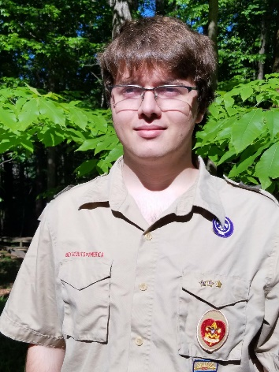
Dominic is a senior at Grady High School and the son of Mary Beth Cutshall and Adam Coletta. He will attend the University of Georgia as a Freshman in August.
Will McConnell began scouting in 2006 with Cub Scout Pack 29 and joined Boy Scout Troup 455 in 2010. While a member of the Troop, Will served as Patrol Leader and has spent his summers as camp staff at Bert Adams Scout Camp.
For his Eagle Project, Will replaced a failing drainage system at Haygood Pre-School using aqueduct technolgy.
Will is the son of Dennis and Lisa McConnell and is a senior at Ben Franklin Academy.
Will joins his father as a second generation Eagle Scout.

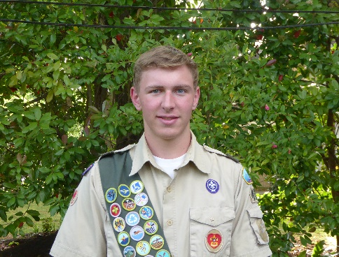
Randall Schwartz joined Boy Scout Troup 455 in October 2011 and has served as Assistant Patrol Leader, Quartermaster, Troop Guide, Patrol Leader and Assistant Senior Patrol Leader. In 2015, Randall spent 10 days trekking through Philmont Scout Ranch in New Mexico.

Randall’s Eagle Project was to reclaim the stone wall from overgrowth and install a brick hardscape in front of the Grizzard House, at Haygood United Methodist Church.

Randall is the son of John and Gigi Schwartz and is a junior at Grady High School, where he is a member of the National Honor Society, the cross country team and the varsity tennis team.

