Scout Oath
On my honor I will do my best
to do my duty to God and my country
and to obey the Scout Law;
To help other people at all times;
To keep myself physically strong,
mentally awake and morally straight.

Scout Law
A Scout is trustworthy, loyal, helpful, friendly,
courteous, kind, obedient, cheerful,
thrifty, brave, clean and reverent.

Eagle Scout Oath
I reaffirm my allegiance to the three promises
of the Scout Oath. I thoughtfully recognize and take
upon myself the obligations and responsibilities of
the rank of Eagle Scout. On my honor I will do my
best to make my training an example and my rank
and my influence count strongly for better Scouting
and for better citizenship in my troop, in my
community, and in my contacts with other people.
To this I pledge my sacred honor.

Eagle Scout Court of Honor

Nick Bennett
Dominic Coletta
Will McConnell
Randall Schwartz

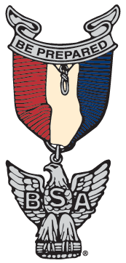

Troop 455, Atlanta, GA

April 29, 2017
Haygood Memorial United Methodist Church

Eagle Scout Court of Honor
April 29, 2017

Welcome David Cox

Invocation Thomas Rudolph

Presentation of the Colors Ashton Edmeades

Convening of the
Court of Honor Jim Pierce

Reaffirmation of the
Scout Oath and Law Vic Reinhold

Eagle Scout Challenge and
Significance of Eagle Rank Mickey Smith

Eagle Scout Charge Bill Jacobsen

Presentation of
Eagle Scout Badge David Cox

New Eagles’ Remarks Nick Bennett
Dominic Coletta
Will McConnell
Randall Schwartz

Closing Jim Pierce

Retirement of the Colors Ashton Edmeades

